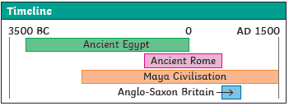
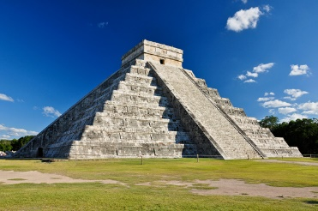
The Ancient Maya

Timeline
2000 BCE | 300 BCE | 900 CE | 1000 CE | 1500s CE | 1839 CE | 2014 CE
The Maya civilization came into being. | Cities, such as El Mirador, become large and powerful. | Cities in the rainforest are abandoned due to an extensive drought. People move north to the highlands of Guatemala and the Yucatán. | Cities like Chichén Itzá (which has two temple pyramids) are still thriving. | The Spanish arrive in South America and set out to destroy the remaining elements of Maya civilisation as part of their conquest. | American explorer and writer, John Lloyd Stephens, and British artist, Frederick Catherwood explore Copán and extensively document what they find, reigniting interest in the Maya civilisation. They go on to document other Maya cities, including Chichén Itzá. | The cities of Lagunita and Tamchén are rediscovered.

Sticky Knowledge
Religion: The Maya believed in and worshipped a number of different gods. They believed that the gods had a good side and a bad side and that the gods could help or hurt them. The Maya would dance, sing and sometimes make offerings of blood to the gods. The Maya people believed that the earth, which they called the Middleworld, was large and flat and resting on the back of a creature, such as a turtle or crocodile. On the Middleworld grew a tree whose branches reached up into the heavens (the Upperworld) and whose roots grew down into Xibalba (the Underworld), which was guarded by gods of death who looked like jaguars. Ordinary Maya people believed that, after they died, their souls would travel through a series of caves and tunnels to Xibalba. Rulers and noblemen believed that they had a chance of getting to the Upperworld.

Writing: The Maya writing system, used to write several different Maya languages, was made up of over 800 symbols called glyphs. Some glyphs were logograms, representing a whole word, and some were syllabograms, representing units of sound. They were carved onto stone buildings and monuments and painted onto pottery. Maya scribes also wrote books, called codices, made from the bark of fig trees. Only priests and noblemen would know the whole written language.

Maya Numbers: The Maya developed a complex number and counting system that was advanced for their time. They were one of only two cultures in the world to develop the concept of zero. The Maya people used just three symbols in their number system. These are thought to represent items that the Maya people might have first used to count with, such as pebbles, sticks and shells. The Maya used a base 20 number system, so after number 19, multiples of 20 were written above the bottom number.

Maya Food: Maize was a very important crop that formed up to 80% of the Maya people’s diets. They believed that the first humans were made from maize dough by the gods. The Maya made a bitter chocolatey drink from cacao beans that was enjoyed by the rich and used for medicines and in ceremonies. The beans were highly valued and even used as a form of money.
Key Vocabulary
Civilisation | An organised society with its own culture and way of life, existing in a particular area over a particular period of time.
Drought | A long period with very little rain.
Rutual | A ceremony, often religious, with set actions performed in a set order.
Jaguar | A big cat, heavier than a leopard, with yellowish fur and black spots.
Scribes | People paid to write things down, either as an official record or for someone else unable to write.
Codices | Ancient handwritten texts. Maya codices could be unfolded like a concertina. One text is called a codex.
Maize | Another word for sweetcorn or corn on the cob. It can be made into a dough and baked into tortillas.
Cacao beans | Cacao trees sprout pods directly from their trunks. When they are ripe, the pods can be broken open to reveal the beans, which can then be dried, roasted and ground.
Syllabograms | Glyphs which represent a unit of sound.
Glyphs | Symbols to represent sounds or whole words.

By the end of this unit the children will:

Show understanding of chronology within periods of time studied such as early events and what led to the end of the time period.

Begin to understand which sources are more reliable and why.

To pose questions to direct research about events and people of the past.

Use relevant historical vocabulary to ask and answer questions.

Describe characteristics of past periods and societies.

Identify and classify the social, cultural and religious aspects of a period.
History Skills

