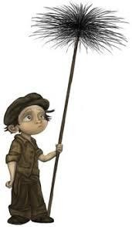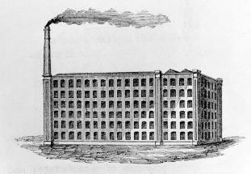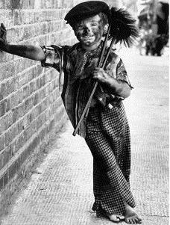 



|  |  |  |  |  |  |
| --- | --- | --- | --- | --- | --- |
| Timeline | | | | | |
| 1837 | 1842 | 1863 | 1870 | 1888 | 1901 |
| William IV dies. His niece Victoria becomes Queen at the age of 18. | Mines Act stops children under 10 from working in underground mines. | First underground railway using steam trains. | Education Act means compulsory education for children between aged 5-10. | First electric power station is opened. | Queen Victoria dies. |

|  |  |  |  |  |  |
| --- | --- | --- | --- | --- | --- |
| Key Vocabulary | |  | Sticky Knowledge |  | History Skills |
| workhouse | A place where the poor were given food and shelter in return for  labour. |  | **Which jobs were Victorian children employed to do?**   * Coal mines - In order to produce more coal, the mines needed more workers and children as young as 5 years old were used to supply this need. They worked for up to 12 hours a day. * Chimney sweep – Chimney sweeping was a job children could do better than adults. Small boys (starting at the age of 5 or 6 years) would be sent scrambling up inside the chimney to scrape and brush soot away. * Factory worker - In textile mills children were made to clean machines while the machines were kept running, and there were many accidents. Many children lost fingers in the machinery and some were killed, crushed by the huge machines.   **Which benefits came with the introduction of railways?**  Railways changed a journey of weeks into hours and was therefore quicker. They helped create the suburbs of the cities and even made it possible to have holidays at the seaside. Trains could also carry goods much more cheaply as the railway tracks could be laid far more cheaply than canals could be dug.  **What was school life like for Victorian children?**  Few children went to school in early Victorian times, this was because they were often sent to work. However, in 1870 school was made compulsory for children aged 5-10 although this did not change much as families could not afford to send their children. In 1891, school was made free. Punishment in Victorian schools was very harsh; children were often beaten with a cane or a ruler or placed in the corner of a room if they answered a question wrong. Children wrote on  slate with chalk and as they got older they were allowed to use a pen in a copy book.  **What was the Industrial Revolution?**  The Industrial Revolution was a time when the manufacturing of goods moved from small shops and homes to large factories. This shift brought about changes in culture as people moved from rural areas to big cities in order to work. |  | By the end of this unit the children will:  Use research to accurately select information and respond to a range of questions  Show awareness of the impact of chronology on events and decisions made by people in the past.  Select appropriate sources from a range of available information and justify their choices.  Compare and contrast between past periods of time and societies.  Understand that events within periods of time can have an impact on decisions made later. |
| industrial revelation | A period where machines and mass production began to take over from hand  making of goods. |
| invention | A new thing that  someone has made. |
| harsh conditions | A difficult place and environment for someone to live or work  in. |
| exploited | To be taken advantage of often so someone can make money out of  them. |
| orphan | A child whose parents  are dead. |
| social class | A group of people who have the same level of  wealth. |
| prosperity | The condition of being  successful. |
| slum | A dirty, overcrowded house or  neighbourhood. |  |  |
| act of  parliament | The name for a law  passed by the British  Parliament. |  |
|  |  |