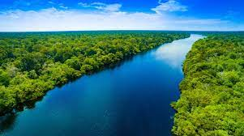
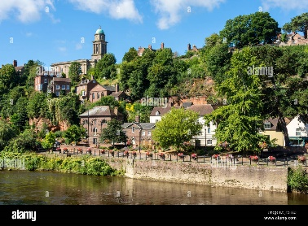
Rivers & Canals

River’s journey
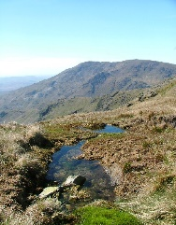  Source | Tributary | Meander | Oxbow Lake | Delta | Mouth
 | 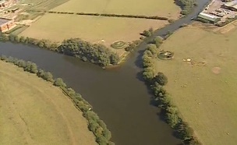 | 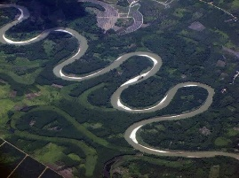 | 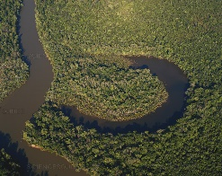 | 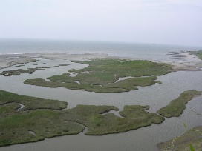 | 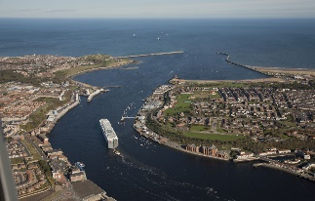
Sticky Knowledge
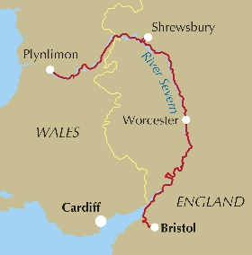
The longest river in the UK is the River Severn (or Afon Hafren in Welsh).

The longest river in the world is the River Nile. It flows
through 11 African countries including Egypt, Uganda
and Kenya.

The largest river in the world is the Amazon River in
South America (and some scientists think it is actually the longest too…)

Rivers have always been important to humans throughout history. Most major towns and cities have been built around rivers as they could be used for food (fish) & drink, growing crops, washing and bathing, travel and trading by boat, and possibly protection from outsiders.

Canals are man-made water roads, created by diverting water from a river in the direction you want it to go. The canal that runs through Audlem is called the Shropshire Union Canal (or ‘the Shroppie Fly’).

Key Vocabulary
Source Where the river
begins.
Tributary A stream or river
which flows into
another.
Meander Where the river
curves.
Oxbow A curved lake which
Lake was a meander cut
off from the river.
Delta Small island formed
from sediment
carried by the river.
Mouth Where the river
meets the sea.
By the end of this unit the children will:

Describe and understand key aspects of: physical geography.

Name and locate some of the countries and cities of the world and their identifying human and physical characteristics

Name and locate the countries of South America and identify their main physical and human characteristics.
Use the eight points of a compass, six-figure grid references, symbols and a key to communicate knowledge of the United Kingdom and the world

Geography Skills

