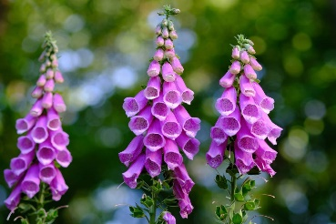
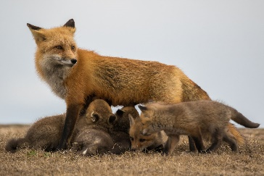
Living Things

Flowers
Stamen (male) | Filament (male) | Anther with Pollen (male) | Pistil (female) | Stigma (female) | Ovary (female)
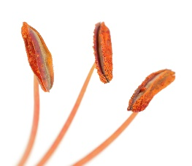 | 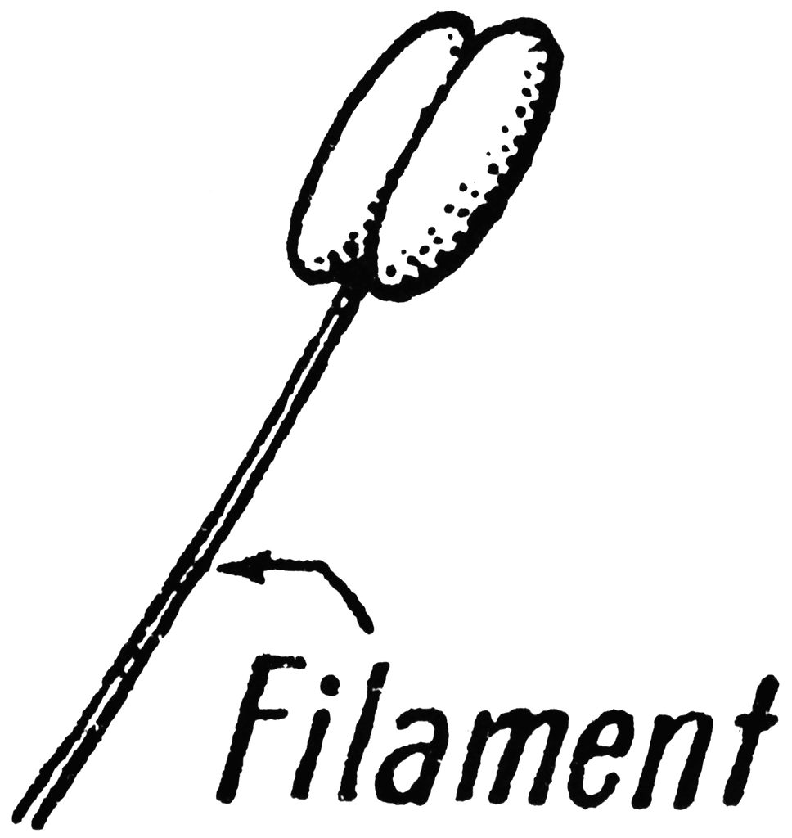 | 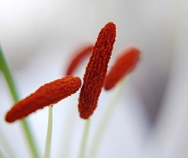 | 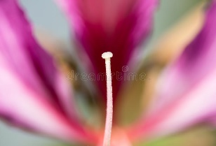
Sexual reproduction | A male and female combining their gametes to create offspring
Asexual reproduction | Reproduction which only needs one parent
Gamete | Male/female cells of animals/plants which join to create offspring
Mrs | Movement, respiration, sensitivity
Nerg | Nutrition,  excretion, reproduction, growth
Life-cycle | Birth -> reproduction -> death (and the changes in between)

Sticky Knowledge
Mammals – warm blooded; have hair or fur; give birth to live young; mothers produce milk for their offspring (except for strange cases such as the duck-billed platypus). Humans are mammals.

Birds – warm blooded; lays eggs; have feathers and wings and are usually able fly (penguins and ostriches are examples of birds which cannot fly)
Reptiles – cold blooded; lay soft eggs on land; have dry scaly skin. Examples include: snakes, lizards, crocodiles and tortoises.

Fish – cold blooded; live entirely in water; have gills for taking oxygen out of water; usually has fins for swimming and lay small, soft eggs underwater.

Amphibians – cold blooded; need a moist place to live; have a young stage that lives underwater breathing through gills and an adult stage which lives on land and breathes using lungs (examples: frogs, toads, newts, salamanders).

Arthropod – an animal which has an exoskeleton, a body with different sections and several limbs in pairs. In other words, insects (such as ants and bees with six legs), arachnids (such as spiders with 8 legs), and crustaceans (such as crabs and lobsters).

What is science?
Science is the exciting study of the nature and behaviour of natural things and the knowledge that we obtain about them.
Using secondary sources: In this type of enquiry, you are trying to answer the ‘big questions’ by identifying patterns in the measurements and observations you research and record. You will learn to compare and evaluate information from different sources. You will learn to recognise the differences between fact and opinion and so develop life skills that will support you in being citizens of the twenty-first century.
Key Questions
How different animals reproduce and grow?
How are plants and animals different?

Scientific Skills
Key vocabulary

